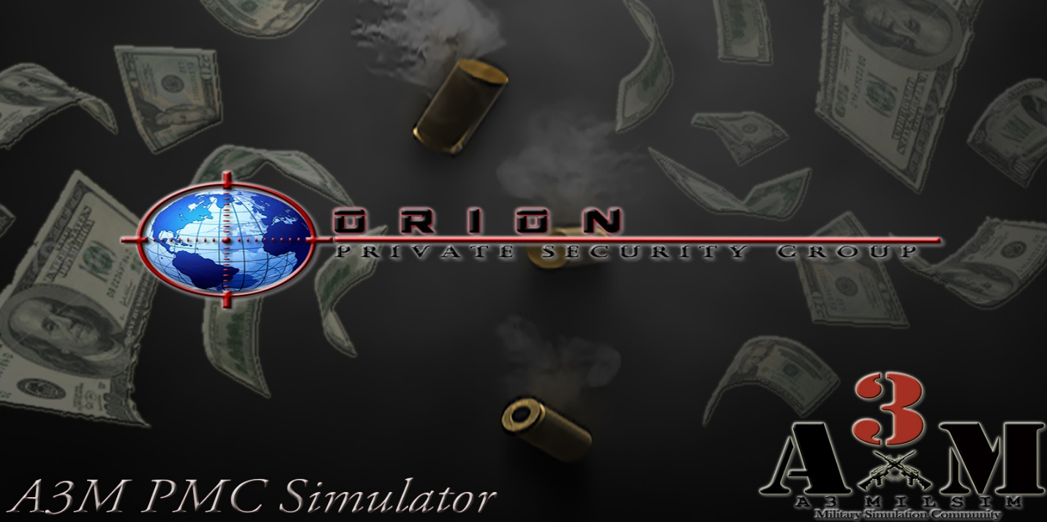

*A3M PMC Simulator*

By: C. Salazar AKA Fr33d0m   
[www.A3MilSim.Com](http://www.A3MilSim.Com)

# Description:

A3M PMC Simulator is a multiplayer mode designed to simulate working as a Private Military Contractor in a conflict zone. You take the role of an Independent Contract Operator brokered by Orion Private Security Group. With a meager starting balance in your bank account and standard-issue sidearm from OPSG, you deploy upon your contractual duties in Altis at the C-12 North compound, an Astral Corporation Research, Development and Communications compound in the NE region of Altis. You will be required to carry out security and paramilitary operations pursuant to your contracts with OPSG, and you will be paid based on performance per operation.



To: CONTRACT OPERATIVE  
From: Orion Private Security Group (OPSG) HR  
Date: 4/26/2030  
Subject: Welcome Aboard!

Greetings! We’re pleased to have you on our team!   
  
Orion Private Security Group is a U.S. Based private security firm that ranked 456th in Forbes fortune 500 list of 2027. Astral Corporation, a large Alternative Medicine and Scientific Research company based in the United States that ranked 12th in Forbes Fortune 500 list of 2027, has retained OPSG’s services to secure Astral’s operations in Altis. OPSG has also managed to obtain small contracts with the local paramilitary police force, known as the Altis Armed Forces.

OPSG supplies a base set of equipment, typically in the form of a basic Pistol Belt, a sidearm (pistol), and some ammunition. OPSG will, on occasion and when deemed necessary by OPSG corporate administration, provide limited supplies of ammunition and equipment free of charge, based on the best interest of obtaining a successful outcome of the operation.

OPSG has secured a vendors contract with Lazarus Military Supply, who acquires various exotic weapons and special equipment and offer them to us at extremely low rates. Any contractor wishing to upgrade his or her gear is responsible for the expense, but may use OPSG’s vendor and special contracts to acquire military grade weaponry for use in the field of duty. Please note that often times, class III (NFA) weapons run at a premium rate due to the legal processing and international restrictions.

As a contractor brokered by OPSG, you will be issued an international bank account through Pursuit Bank. Through OPSG’s special partnership with Pursuit Bank, they’ve developed a software that will allow you to submit your time and activity reports directly to OPSG’s HR department through the bank’s website, which will in turn allow OPSG to immediately bill Astral Corp’s HR Department and pay you for services rendered! Such are the benefits of working for a top tier security organization!

We hope you enjoy your employment with our organization! Welcome Aboard!

Sincerely,

-Orion Private Security Group   
Human Resources Dept.

# **Roles & Command Structure:**

The A3M PMC Simulator is designed to be played by clans or groups of friends who play together, and have a defined leader. The Team Coordinator (Clan Leader) has control of a majority of things in this mission, including the operational budget and the purchase of vehicles and aircraft. As of this version (0.98.1 Alpha) there are a variety of instances where the honor system is employed…For example, the mailbox, anyone can access it. The lockers can be accessed by anyone, there are no locks yet. Such reinforces playing this mission with people you know to get the best benefit. Since Task Force Radio is a requirement of this mission, it again reinforces that everyone be in contact and be able to communicate, which helps in keeping people honest.

1. **Team Coordinator:**  
    The Team Coordinator is the top slot in the mission and carries the rank of “MAJOR”. This is the only rank that can spend from the Operational Budget (Buy Vehicles and Aircraft), and has full control of the operation’s spending. While not restricted by code, this is also the person who should access the secure email system to start missions. The reason this is NOT restricted by code is so people can continue to enjoy the mission after the Team Coordinator has logged off, or if the TC is unavailable to start a new mission. See more about the Secure Email System in the “Accessing the Internet / Secure Email System” section of this document. By design, the Team Coordinator is also in operational command of OPSG ops in Altis. NOTE: LOGGED AS ADMIN gives a single player (optimally, the team coordinator) access to Zeus. Log in as admin and hit Y to open the Zeus interface, and create missions and spice up situations on the fly!
2. **Medics:**   
   Medics are ACE 3 enabled medics, and carry the full responsibility of providing medical care to wounded soldiers. The need for this is elevated by the fact the death means one of two things: A team mate loses thousands-of-dollars’ worth of gear, or, surviving team members are stuck managing a dead body or the dead guy’s gear until the new spawn can come and claim his remains. This means that saving lives is a top priority, and a VERY important job!
3. **General Contractor:**   
   The General Contractor is the heart and soul of the Private Security Group, and his or her responsibilities vary greatly from operation to operation.

# **Budget, Bank Account and Making Money:**

## **Dual Budget System**

 In the PMC Simulator, there are **two** separate running budgets. The Team Coordinator has control of the Operation Budget. This budget, by default, starts at $12,000,000.00 (You can change this in the Mission Parameters). The Team Coordinator may purchase vehicles, aircraft and armor with this budget, as well as advance 10k to every player out of it. Additionally, every time a player refuels, rearms or repairs a vehicle, the cost of parts, labor, ammunition and fuel are calculated based on the amount needed, and charged to the Operational Budget. The cost of Fuel and the Hourly Rate of Labor can be adjusted via the Mission Parameters.

Parallel to the Operation Budget that is controlled only by the Team Coordinator, every player has a personal bank account, in which he or she may use to purchase equipment for use in the field.

With every contract mission completed, **two payouts occur**. The first, a payout of rating points to the player, which he or she must then submit in the form of a “Time Sheet” via the Pursuit Bank Interface, the rating points are converted and deposited into the player’s bank account as payment for services rendered. The multiplier for rating points can be adjusted via “Mission Parameters”. The second payout occurs immediately, and is applied to the operational budget balance. This can only be spent by the Team Coordinator on vehicles or aircraft, or may be “advanced” to players via the button.

## **Rating Points: The Behind - The - Scenes Currency of the PMC Simulator**

The payout system in the PMC Simulator is based off of performance. Rating is added in a static amount for completing various contracts, and in the Arma default amounts for kills. The more kills during a mission, the more money you’ll make. Doing negative things will COST rating, such as killing team mates, killing civilians, etc. It is possible to achieve a negative rating, which would then make the player unable to acquire additional funds until sufficient good work was done to bring the rating back to a positive. Alternately, a player may buy out of a negative rating by submitting a timesheet with the negative rating, which will subtract the payout multiplier x the negative rating from the player’s account to cover for the bad behavior. If the player doesn’t have the funds to cover the bad behavior, the player may find themselves with a negative balance in the bank, unable to purchase even something as small as ammo.

**Bank Account:**   
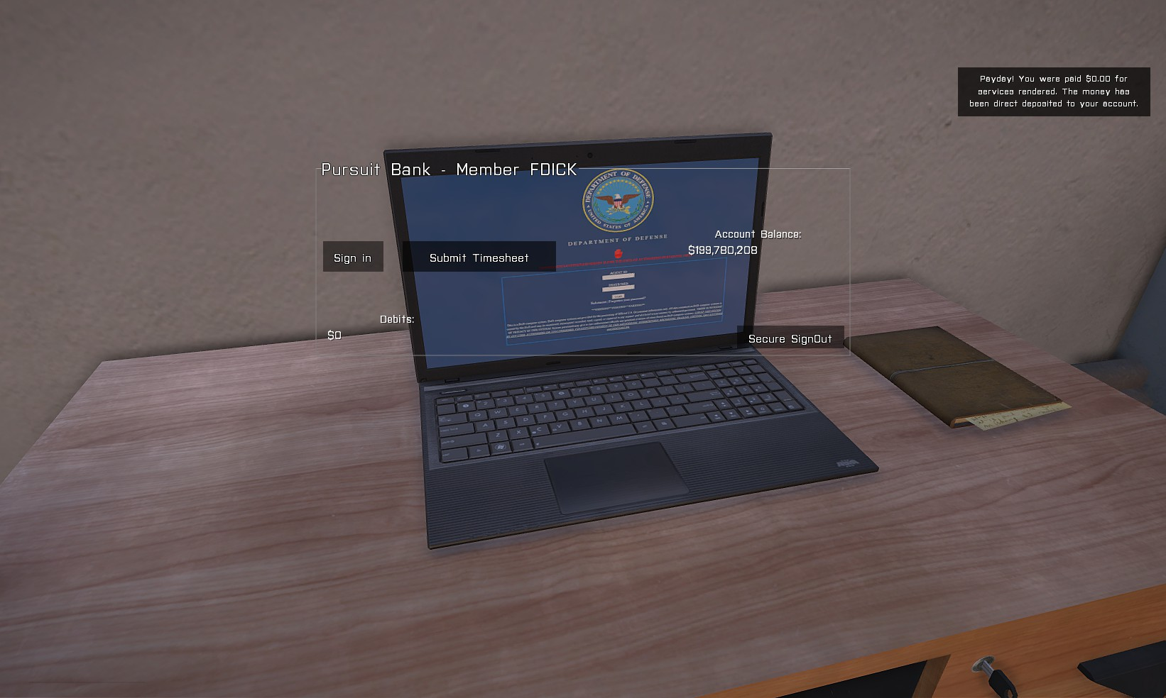The PMC Simulator features a persistent bank account for all players. This balance will persist through server restarts and over different servers running the mission. To access the bank account, visit a Computer and access “Personal Banking” via the Action Menu. You will be presented with the “Pursuit Bank” interface, where you will need to sign in prior to submitting your Timesheet, as well as view your account balance and debit amount of recent purchases.   
  
As mentioned above, in order to earn money, you must earn rating points by successfully completing missions and killing hostile enemies. Killing innocents or friendlies will severely impact your rating in game, therefore negatively impacting your account balance.   
  
After completing a mission, or whenever you have rating points built up and ready for deposit / conversion to money in your bank account, simply visit HQ or another location (Such as a safe house) to access a laptop and open the Pursuit Bank Interface, then click the “Submit Timesheet” button to collect your payment.

**Accessing the Internet / Secure Email System:**

In the PMC Simulator, a laptop is your connection to everything that matters. In addition to the all-important banking interface, you can “Shop Online” for weapons, ammunition and all other equipment, “Check Email” to review and accept contracts on behalf of Orion Private Security Group, and additional actions (Mainly for the Team Coordinator). All of these modules are summed up in a graphical representation of a secure website. Simply click a link on the “home page” to access the module you desire.

## Email System:

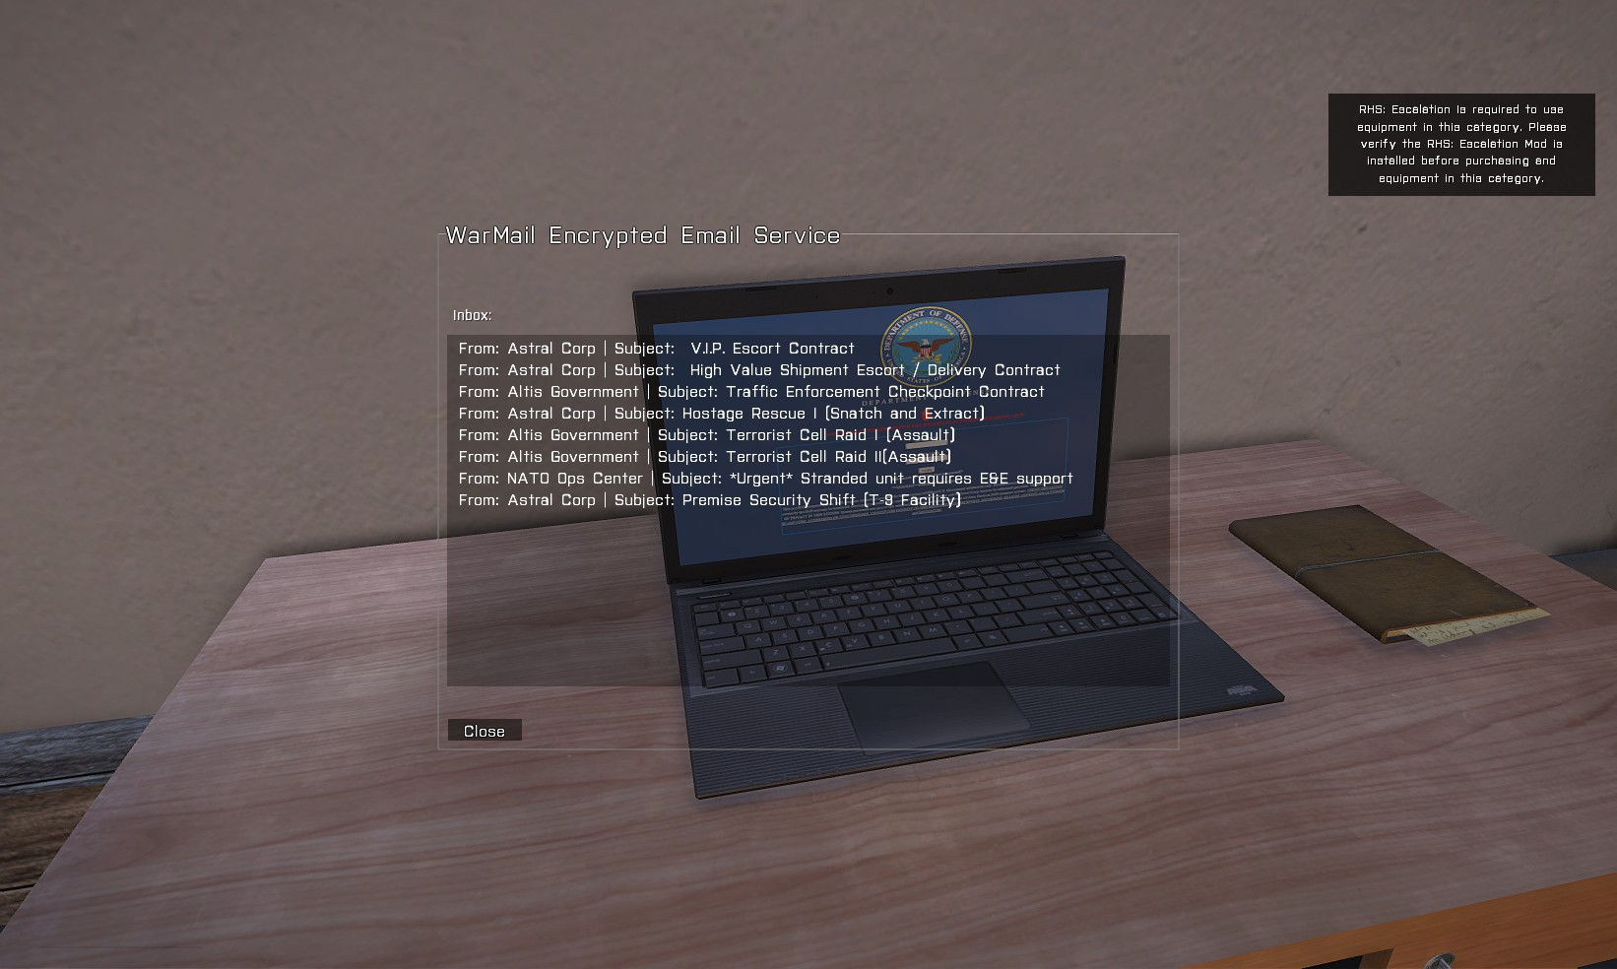

The primary method for accepting contracts in the PMC Simulator is via the “WarMail Encrypted Email Service”.   
  
The **“From:”** line designates the client the contract is offered by.

The **“Subject:”** line designates the type of contract.

To accept a contract, DOUBLE CLICK the line of the contract you want to execute.

The Team Coordinator can cancel ALL missions via the admin panel.

## Fleet Management:

The Team Coordinator is responsible for all purchasing of Fleet (Vehicles and Aircraft) for the Altis Operation. The Team Coordinator must carefully plan every operation and allocate assets accordingly, so that adequate assets are available for every mission. To purchase a vehicle or aircraft, click the appropriate button on the main screen and then double click the vehicle or aircraft you would like to purchase. Vehicles will be delivered to the C-12 compound, in the field east of the C-12 Main Gate. It is marked clearly on the map with “Fleet Delivery”. Aircraft will be delivered to the Astral Corporation Owned Molos Airfield in the NE corner of Altis.  
  
PMC Simulator supports RHS: Escalation, and you will find all the RHS: Escalation vehicles by selecting the “RHS: Escalation” option from the drop-down box, then clicking a category to load the RHS: Escalation vehicles from that category.   
  
All vehicles have been painstakingly researched, and are priced at real world market values of 2015. Some equipment is estimated based on close counterparts.

## Shopping Online & Personal Purchases:

To access Lazarus International Security Supply, access a laptop and select “Shop Online” from the action menu. You may then purchase a weapon, ammunition, vests, bags, electronics, medical supplies and other items from the corresponding categories by double clicking. WARNING: There is no “ARE YOU SURE” safety to this function. It is easy to spend money accidentally! Once you have made your purchase, you will need to wait the “Delivery Time” for your equipment to be delivered “via freight” to the large delivery locker in the C-12 Operations Headquarters (The Big Green Locker with the big yellow arrow over it.)

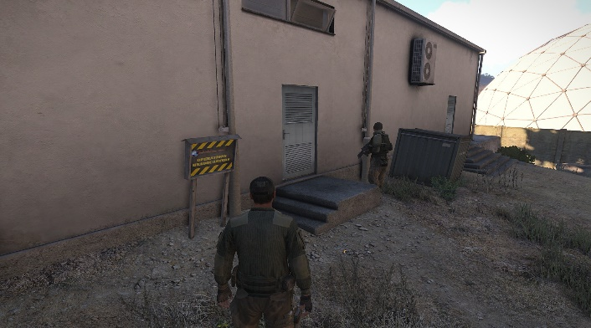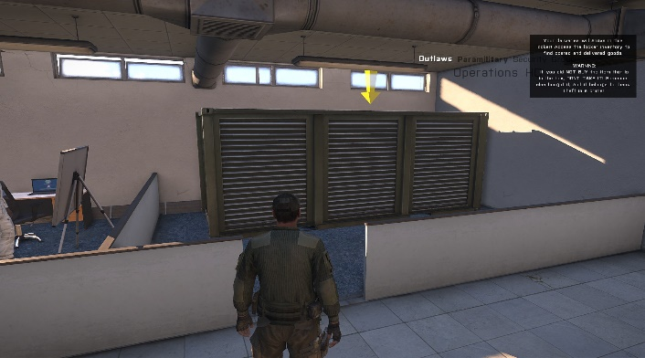

# **Fast Travel:**

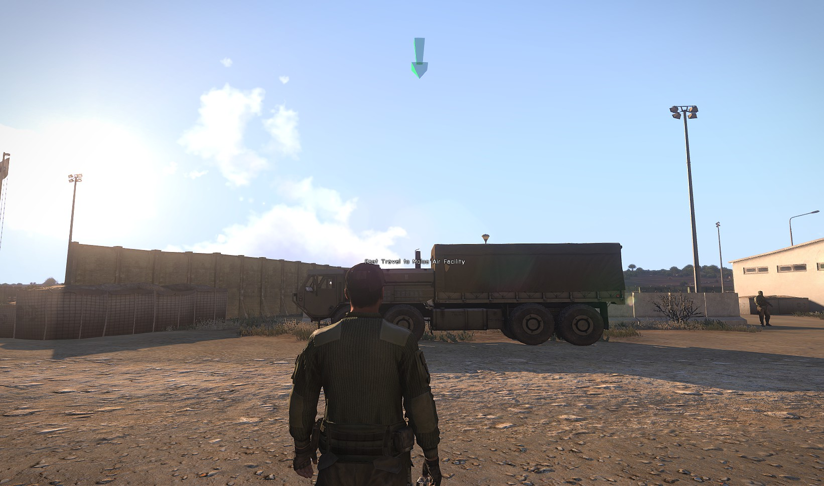

Fast Travel between the C-12 Compound and Molos Airfield can be facilitated by utilizing the HEMTT Transport’s action menu option to “Fast Travel”. The user will experience a short loading sequence, followed by a teleportation to the destination. As of Alpha 0.98 – You must exit the HEMTT before fast traveling a second consecutive time, otherwise, you will wait through the loading sequence and end up right where you started, with no teleportation. *This is slated to be addressed in coming versions*.

# **Wildfire Protocol Safe houses:**

On the map screen, a series of large, orange triangles depict seven locations strategically located throughout Altis. These locations, known as “Wildfire Protocol Safe houses”, provide generally safe locations for Orion teams to retreat to in the event of prolonged or severe combat. Wildfire Protocol safe houses are equipped with medical equipment, limited ammunition supplies, a laptop with internet access (Purchased items will still be delivered to the C-12 compound) and two empty supply lockers nearby on the property which can be filled with any kind of supplies deemed necessary by the Team Coordinator of OPSG staff.

# **Other Facilities & Features:**

# C-12 Facility

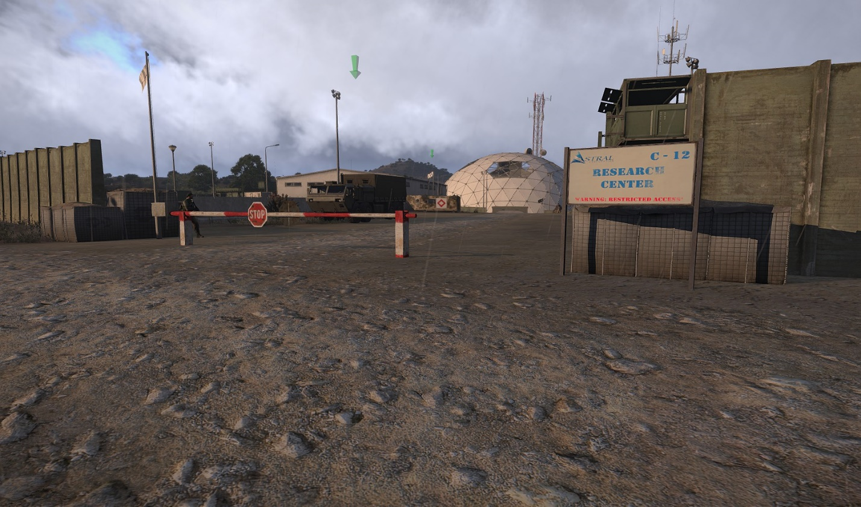  
The C-12 Facility is a Biomedical Research Facility owned by Astral Corporation that has been allocated partially to Orion Private Security Group for operations in Altis Theatre.

The C-12 Facility is equipped with a medical and detention / interrogation facilities as well as office facilities for the Operations HQ, and mechanical facilities for vehicle service. It is equipped with a helipad in the western end of the compound, and all security gates are equipped with RFID sensors for automatic operation.   
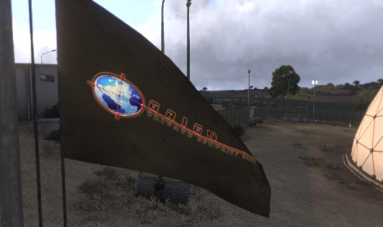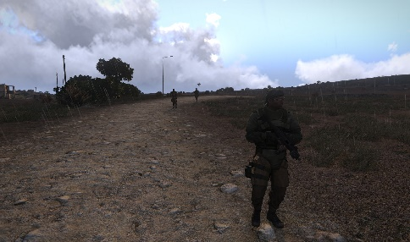

## Medipod Field Hospital:

The Field Hospital medipod is an ACE 3 enabled medical facility capable of supporting advanced medical procedures. To use, enter the medipod with a medic and allow the medic to treat you. You should be able to fully heal inside this medipod.  
  
By default, the ACE 3 medical modules are set to the most advanced / difficult settings. You are encouraged to DePBO (Or acquire the DePBO’d version from http://www.A3MilSIm.Com/A3M_PMC_Simulator.html) this mission to change the ACE3 settings to best fit your preferences.   
  
ACE 3 Medical supplies are for sale via the online store, ACE 3 mod filter, and then click “Medical”.

## Operations HQ:

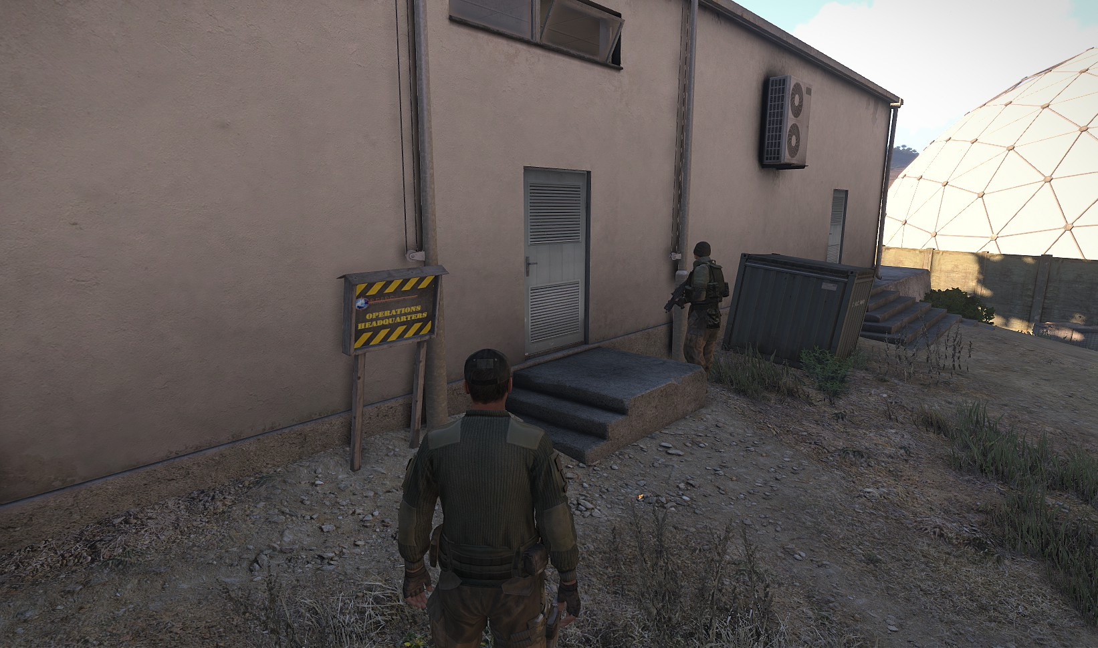

The Operations HQ is a Role-Play encouraging center for operational planning and downtime actions like shopping online. The OHQ is the location of the Mail Locker (Where things purchased are delivered) and where several Laptops can be found for access to the internet.

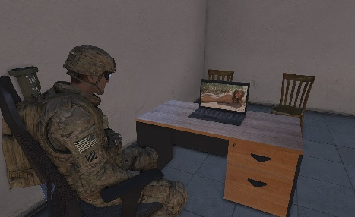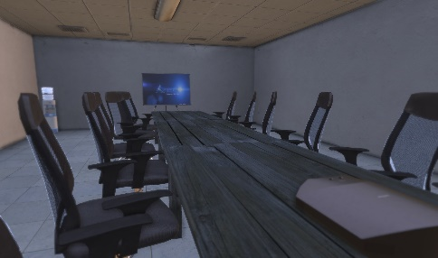The Conference Room supports MP Compatible slideshows, and can be changed with a little editing. Every chair is sit-down enabled. Change the slide from the projector on the table.   
  
The Eastern-Most office is the Team Coordinator Office. This laptop will host any TC Specific Actions (If Any).

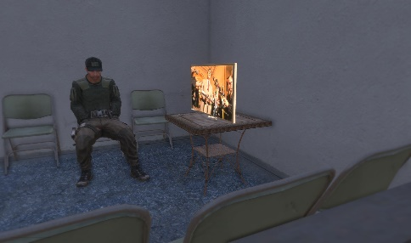

Water coolers will refill your stamina!

All televisions are MP Compatible, and can be turned on and off!

## Detention Center:

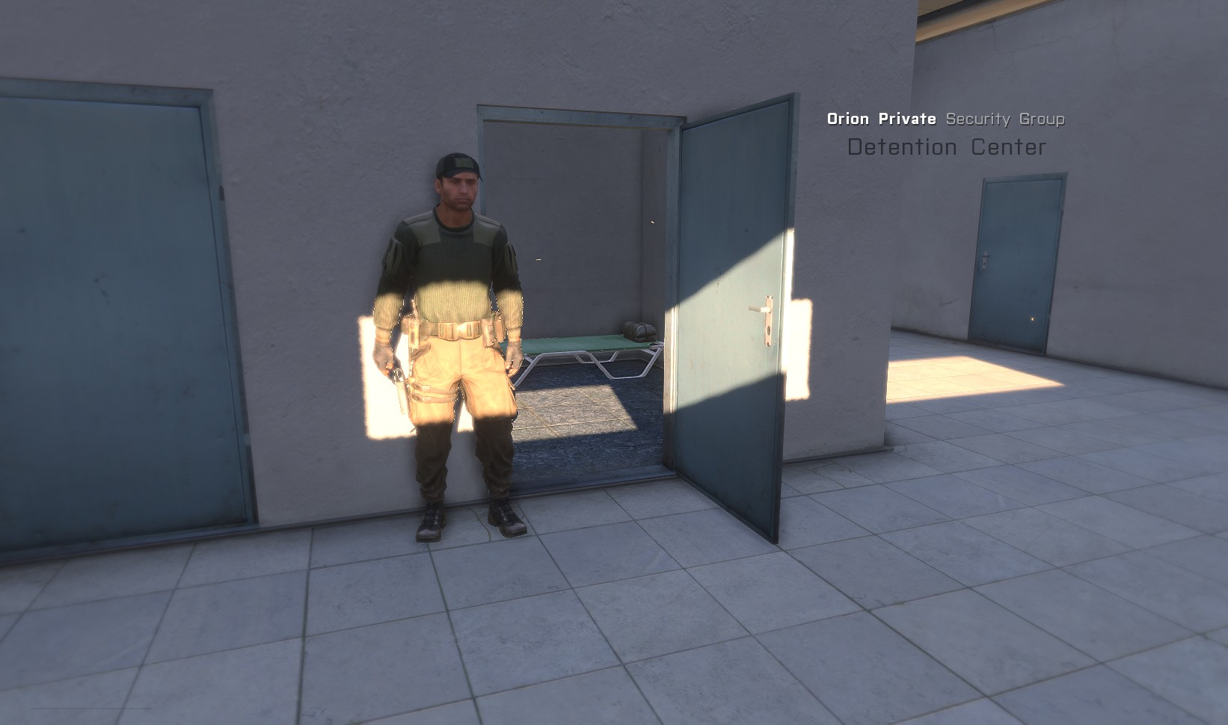

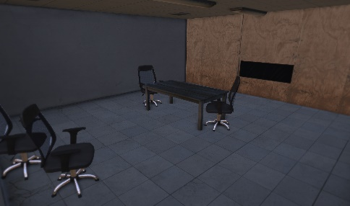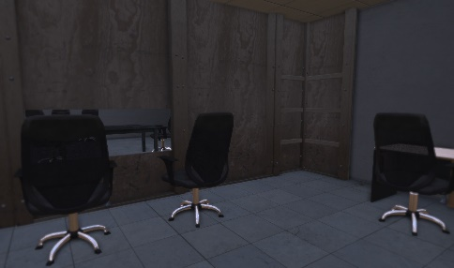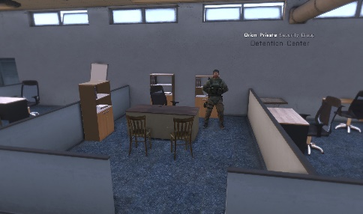The OPSG Detention Center is a holding and interrogation facility. With lockable doors and a “Security Mode” feature, as well as a fully functioning 2 way mirror interrogation room, some interesting things can happen in here!   
  
To enter security mode, find the Warden (At parade rest in the main room) and look at the bookshelf behind him. Use the action menu to enter the observation room or enter “Security Mode” which will add the option to lock and unlock most doors in the facility via the action menu. To remove all the actions, select “Security Mode Off”.

## Automotive Service Center:

At the automotive service center, you can repair, rearm and refuel anything that sticks to terra firma, from 4 wheels to tracks. Simply enter the yellow light marked area, and the service center will calculate the damage sustained and the real-world equivalent of the approximate time it will take to repair it (You won’t actually have to wait this time) and then calculate the cost of parts and labor.   
  
For the re-arm stage, the service center will calculate how much ammo was used out of each weapon, and then charge an amount for the ammo that needs to be replenished, saving the ammo that wasn’t used. The ammunition / rearmament price calculated is based on generic real world approximation per round / magazine.

In the final stage, the service center will refuel your vehicle based on how much fuel was used, and the cost of fuel (adjustable in the mission parameters).

Upon completion of the service regimen, the total bill will be displayed to the driver of the vehicle, and will be debited from the OPSG Operational Budget. If there is less than 5k in the operation budget at the time of the service center visit, the service will be denied.

# Molos Airfield / Aircraft Service Center:

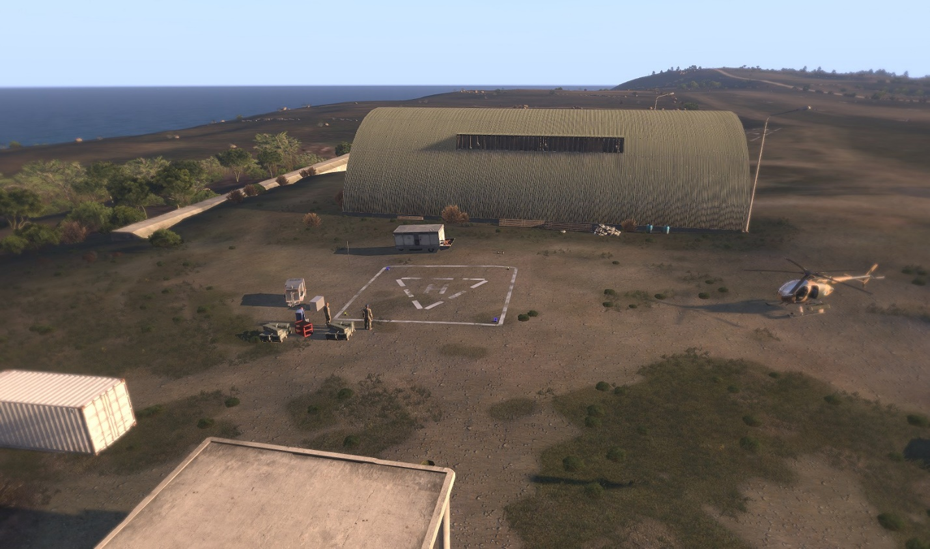

The airfield works much like the ground vehicle service center, in that it calculates parts / labor, the cost of rearmament (proportioned to aircraft grade equivalents), and the cost of refueling (The price of jet fuel can be adjusted in the mission parameters).   
  
Fly into the helipad area and wait for the ground crew to begin waiving you in. Upon touchdown, another member of the ground crew will come to your helicopter and service it. Upon completion, you will be free to continue operations, and OPSG will be billed the service fees.

# Altis Rifle Club

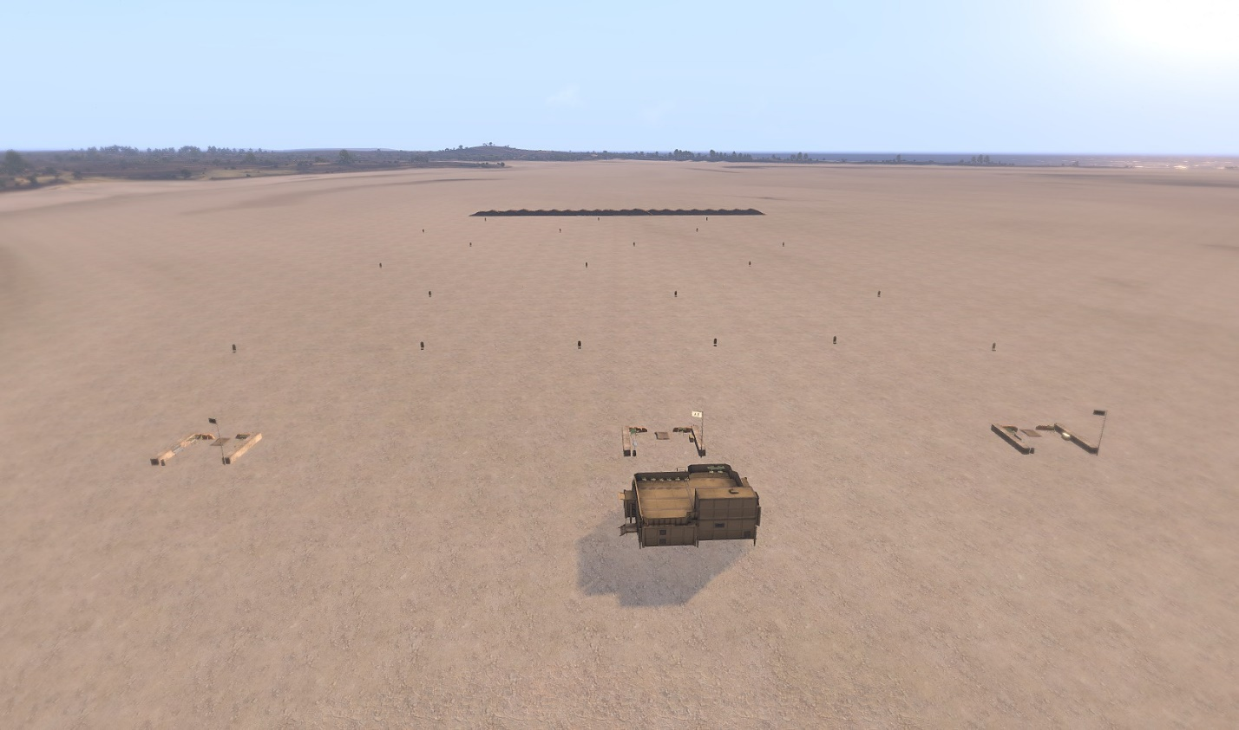

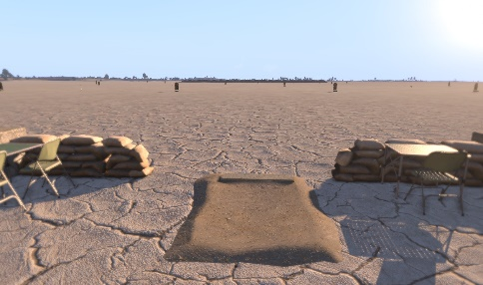The Altis Rifle Club is a fully functional 3 lane pneumatic range with scorekeeping and manual target control.   
  
Marked on the map and located ESE of the C-12 facility, the Altis Rifle Club is a perfect place to practice shooting at various ranges as well as qualify with a weapon.   
  
To Use: Approach the laptop computer atop the Observation Structure and take a seat. Use free-look to access the “Range Control” via the action menu, and then have your shooter take a place on lane A, B or C (Marked by white flags at each shooting position)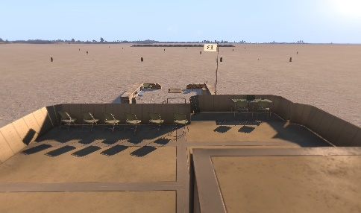

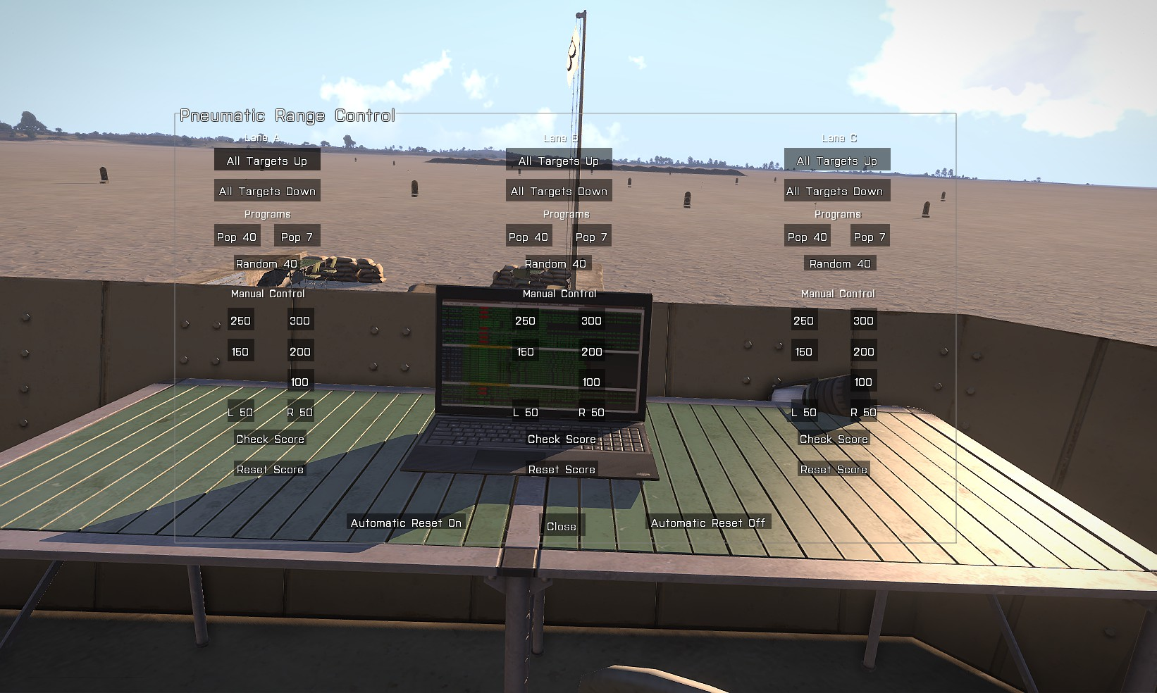

Click “All Targets Down” to set the range for a program.

Click “Automatic Reset Off” to set targets to stay down after being shot. This is very important when running a program!! Click “Automatic Reset On” to make targets pop back up automatically after every hit. This is a great mode for practicing by yourself.

Each column of controls on the Pneumatic Range Control Panel represents the corresponding lane as you see it, and as labeled.

The POP 40 Program is designed to replicate the real US Army M4 Rifle Qualification Program, and will spawn a programmed volley of targets, including some double targets, in sets of 20 – 10 – 10 (20 prone, unsupported, 10 prone supported, 10 from a kneeling or crouched firing position). Typically, a shooter is limited to 20 rd. magazines, and is only allowed 40 shots. The final score is calculated by targets popped / targets hit.

The POP 7 Program is a slow, beginner level program, best for teaching the basics of weapon usage.   
Random 40 is a WIP, and not yet functional.   
  
Manual Control allows the Range Master to pop each target individually for 3 seconds each. This allows the Range master to execute a custom course on the fly. The buttons are labeled the range of the target, and are arranged according to the position of the targets on the lane.   
  
Check score will display the current score for the corresponding lane, and reset score will reset it to 0.

# **Missions:**

## VIP Escort

The player who starts the mission will have an Astral Executive spawn as a member of his or her group. All players will receive a task designating the VIP’s randomized destination. Your job is to select the safest method to deliver your VIP to his destination, and get him there safe. If he dies, you fail.

## High Value Shipment Escort

A box truck will spawn just out front of the C-12 HQ on the road. All players will receive a task designating the vehicle’s randomized delivery destination. Get the truck to its destination in one piece. If the truck is destroyed, you fail.

## Traffic Enforcement Checkpoint

All players will receive a task designating the location of checkpoint C-12 North, located north of the Altis Airport on the main highway. Upon reporting to the checkpoint, a mission will begin in which a series of randomized drivers, entering randomized vehicles and having randomized situations and behaviors.

## Hostage Rescue I (Snatch and Extract)

All players will receive a task indicating the last known location of an Astral Corp Executive. All players will have a new marker on their map as well, which depicts the location of the Astral Executive in real time by way of an emergency transponder voluntarily implanted sub dermally in most Astral Corp executives working abroad in dangerous countries for reasons just like this. The executive will be held by violent captors, so surgical extraction of the VIP is a requirement. Once the fighting starts, the hostage may break free and run for his life. The Emergency Transponder should keep you informed on his location via the map at all times.

# **Supported mods:**

The Following Mods are SUPPORTED / Required:   
  
[*ALiVE*](http://alivemod.com/)[*RHS: Escalation*](http://www.rhsmods.org/)[*ACE 3*](http://ace3mod.com/wiki/development/setting-up-the-development-environment.html)[*Task Force Arrowhead Radio*](http://radio.task-force.ru/en/)[*Leights OPFOR Pack*](http://www.armaholic.com/page.php?id=27353)

# **Known issues:**

Some players may experience cropping of GUI Menu options. Work Around: Ensure via Arma display options that the "interface size" option is set to "normal" or "small". This should fix most cropping issues.

# **Changelog:**

### V0.91.8 Alpha

* Changed: Name of Mission
* Added: Custom Artwork
* Added: Division HQ
* Changed: All GUIs
* Added: RHS: Escalation Support (All vehicles, Items, Weapons, etc.)
* Added: ACE 3 Support (All ACE 3 Items & Electronics)
* Added: Task Force Radio Support (All TFAR Electronics)
* Removed: Support for all previous mods
* Added: ACE 3 Field Hospital
* Added: Multiple Multiplayer Parameters – Economy (Gas Prices, Cost of Labor, Etc.)
* Added: Detention Center (2 way mirror room, lockable cell doors)
* Added: Usable Shitter (Latrine Facilities, and “Take a shit” option)
* Added: Water Cooler (Drink to restore stamina)
* Added: MP Compat Television, Projector, Radio (Ambient Music)
* Added: New PMC Base Load out and OPSG Uniforms
* Added: Economic Considerations of Repairs, Rearms, and Refuels
* Changed: Delivery Box Model
* Added: More Playable Slots
* Added: Manual Garbage Collector
* Added: A3M Firing Range (Altis Rifle Club)

### V0.91.5 Alpha

* Added: Reinforce and Extract Mission
* Added: Astral Corp T-9 Facility
* Added: T-9 Premise Security Mission (WIP)
* Fixed: Checkpoint, 100% Rebuild again, everything should work as intended now.
* Added: New audio files
* Added: RFID Gate system to C-12 Facility
* Updated: C-12 Facility

### V0.91.1 Alpha

* Added: Siege II Mission
* Changed: How Siege missions spawn enemies and how enemies defend the controlled areas.
* Added: ACRE 2 Support in store, AN/PRC 343 and AN/PRC 148 available for purchase.
* Removed: Task Force Radio Dependency
* Fixed: Some Checkpoint bugs, hopefully no more civs running alongside vehicles or vehicles showing up in doubles with no options.
* Added: Bug fail safes to Checkpoint. Now if/when things go haywire, it should have some backup plans in place to keep the mission going and stable.
* Added: 1/30 Chance of enemy group attacking checkpoint.
* Added: 2/10 Chance of enemy ambush at destinations for VIP Escort and Vehicle Delivery missions.

### V0.91 Alpha

* Removed: Pesky Selectable Respawn with buggy forced respawn on start.
* Added: Backpacks to store
* Added: Headgear to store
* Added: Initial Budget now adjustable via Mission Params.
* Added: Various Sound Effects, Dispatch Framework.
* Fixed: VIP Mission Trigger Bug

### V0.9 Alpha

* Added: Major GUI Changes!!
* Full Internet GUI redesign
* Moved Email to Internet GUI (Can now access Email missions from any computer enabled)
* Added Admin Panel
* Moved 10k To All Button to Admin Panel
* Added "Force All Mission End" button to Admin Panel
* Added Mod Drop-Down box (Select your mod, then click the category to see mod-filtered weapons or item)
* Fixed Bank Account Balance to load at mission load, so no losing money if you forget to sign in first.
* Added: Siege Mission I

# **Scripts & Modules**

Features & Modules – By Fr33d0m

* A3M JIP Script – Handles JIP tasking
* A3M Economy Script (unreleased version, pending)
* A3M Bank Account Script (standalone unreleased, pending)
* A3M Sitting Script (Seats your ass in a chair, MP Compatible) (Standalone unreleased, pending)
* A3M Missions by Email Script (Email Interface to start missions) (Standalone unreleased, pending)
* A3M Detailed Animations – cinematic